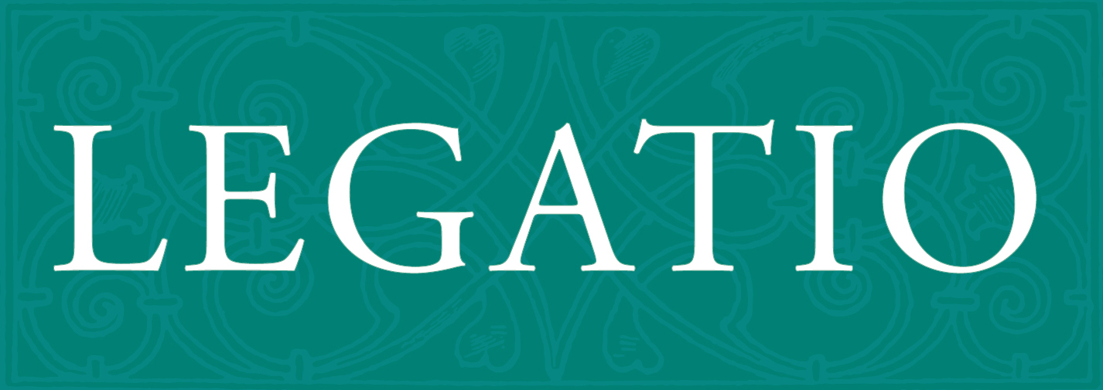

Legatio: The Journal for Renaissance and Early Modern Diplomatic Studies

Article Review Sheet
Article title:

Scale: 5 - excellent, 4 - good, 3 - satisfactory, 2 - poor, 1 - very poor
 | 5 | 4 | 3 | 2 |  | 1
Content:
Writing style:
Bibliography:
New approach:
Suggested decision:
1. To be published
2. To be published after corrections
3. NOT to be published

Comments:

(Please use more space if necessary)
Reviewer: |  |  |  |  | Date:

